# MP 2 Writeup

**Team Members:**

Ritvik Goradia (Goradia3)

Aumkar Renavikar (aar8)

Devul Nahar (danahar2)

Toby Liang (tobyzl2)

1. How do you choose the parameters for the controller? How long does it take for the vehicle to run one lap around the track?

It took our vehicle 3 minutes 47 seconds to go around the track. The parameters we chose the k values as follows:

k_x = 0.1

k_y = 0.05

k_v = 0.5

k_theta = 2

For steering, we took 0.5 for velocity (we had the minimum D gain). We minimize the velocity so that we have more time to adjust since the car speed is slower. But we took the maximum D gain for steering, which was 2. We want to maximize the steering because when we are deviating from the waypoint, we can make quick adjustments to get back on track. We set kx and ky (p gain) to low values so that in the sharper corners, our car would move slower and wouldn’t topple over when we turn.

1. Draw an x-y plot recording the trajectory of the vehicle around the track. In addition, you should mark the default initial position and the waypoints in your plot.

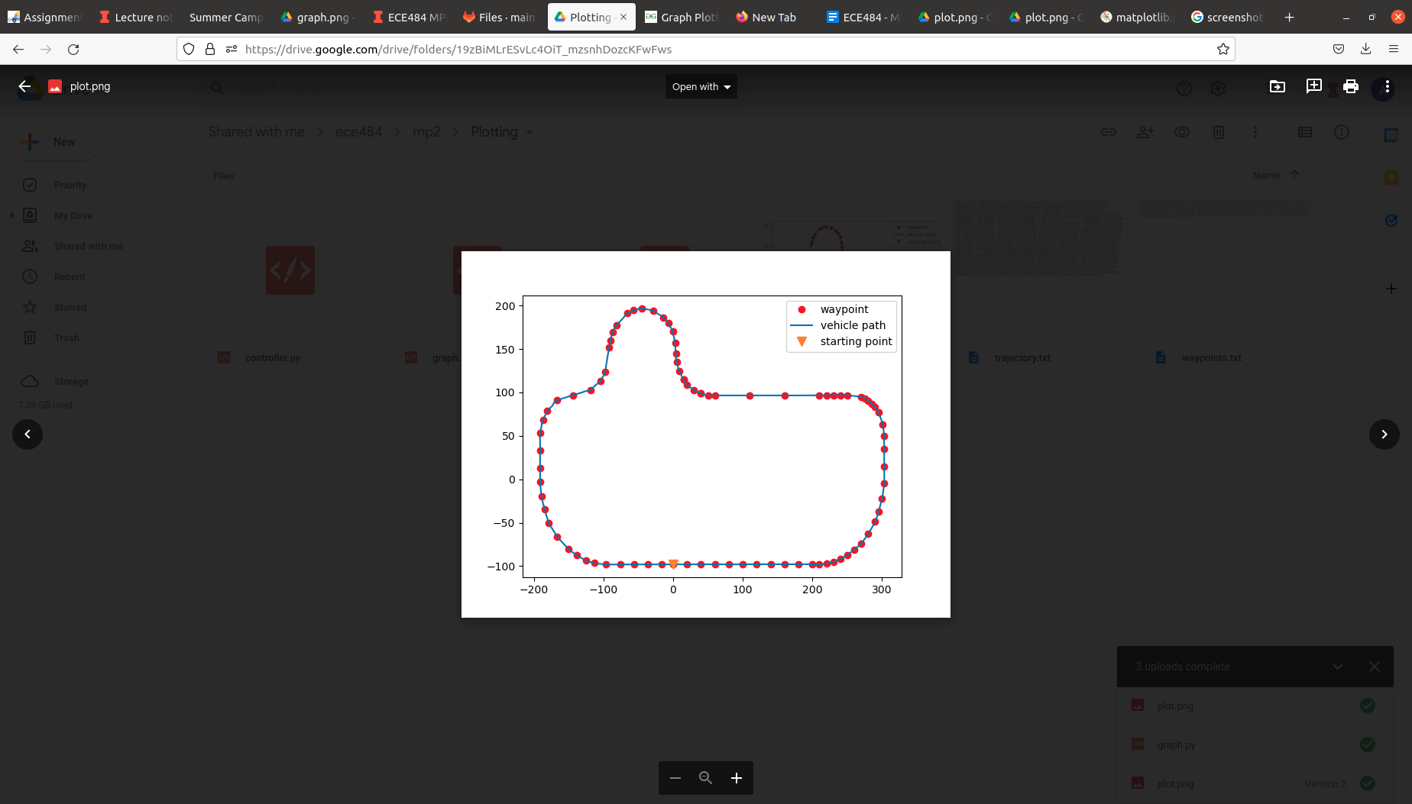

1. Record a video for one example execution of this scenario. The video should include the GAZEBO window. Provide a link to the video and include it in the report

<https://drive.google.com/file/d/12dbqiPECcZTXr53ZFgKEZ1Yhazt24Sjs/view?usp=sharing>